

Practices for Secure Software Report

Table of Contents
Document Revision History 3
Client 3
Instructions Error! Bookmark not defined.
Developer 3
1. Algorithm Cipher 3
2. Certificate Generation 4
3. Deploy Cipher 5
4. Secure Communications 6
5. Secondary Testing 7
6. Functional Testing 9
7. Summary 12
8. Industry Standard Best Practices 14

Document Revision History

Version | Date | Author | Comments
2.0 | August 12, 2026 | Mohamed F. El-Hewie | - Dependency vulnerably  - Checksum deployment  - Certificate of Authority  - Secure Connection  - Code Refactoring

Client



Developer
Mohamed F. El-Hewie

Algorithm Cipher

  - To ensure data integrity, we utilize SHA-256, a robust cryptographic hash function designed to be collision-resistant (Manico & Detlefsen, 2014, Chapter 6). This mathematical algorithm maps any variable-length input to an irreversible, fixed-length 256-bit (32-byte) digital fingerprint, making it computationally infeasible for distinct inputs to produce identical outputs, making data-collisions virtually impossible.

  - The SHA-256 function represents this signature as a highly secure 64-character hexadecimal string. By preventing data collision, the cipher guarantees data integrity. This primarily works by generating a unique fingerprint of the data, ensuring comprehensive information security. (Dizon & Meehan, 2025, p. 82).

  - The SHA-256 cryptographic algorithm turns input data into a deterministic hash value from a pool of 2²⁵⁶ numbers. This creates unpredictable fingerprints so hackers cannot guess them. Unlike hashing, encryption and decryption use numerical keys generated from random numbers - from true physical noise or complex software math generators. Symmetric keys lock and unlock data very fast and handle large files with ease. However, symmetric keys require a safe way to share the secret key -between endpoints- beforehand. In contrast, asymmetric keys encompass public and private keys – a public key is used to lock data and a private key to unlock it. That solves the problem of sharing secrets safely over public lines, but takes more computer power and runs slower than symmetric options.

  - Early encryption relied on mechanical letter shifts, like the Caesar cipher and World War II Enigma machines (Antal, Mírka and Kováč, 2026). As computer hardware advanced from vacuum tubes to solid-state transistors, data speeds and sizes grew rapidly. This massive growth led to the Advanced Encryption Standard (AES) becoming the modern global benchmark for data security. The encrypted data can be transmitted securely between endpoints, only to be decrypted back into the original data by the owner of the secret decryption keys.

Certificate Generation

  - To streamline the development process, a self-signed certificate was generated using the Java keytool command-line utility, eliminating complex file-path configurations and allowing for swift configuration and successful compilation within the Eclipse IDE. Once the Java application was deployed with this integrated certificate, it successfully resolved SSL/TLS handshake untrusted authority errors, enabling secure and authenticated access to the local endpoint at “https://localhost:8443/hash” without requiring modifications to the Windows Defender Firewall rules.

i. Self-generated certificate “elhewieCA2.cer.”

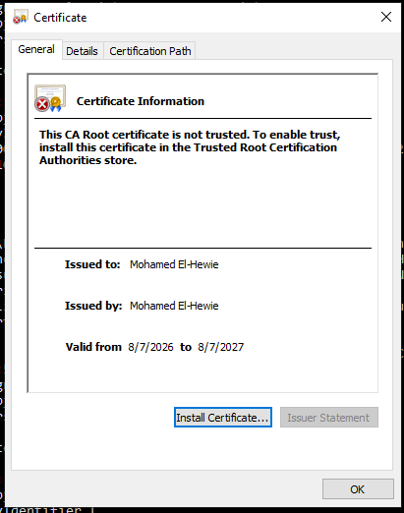

ii. The command-line printout of the internal details of the certificate is as follows:

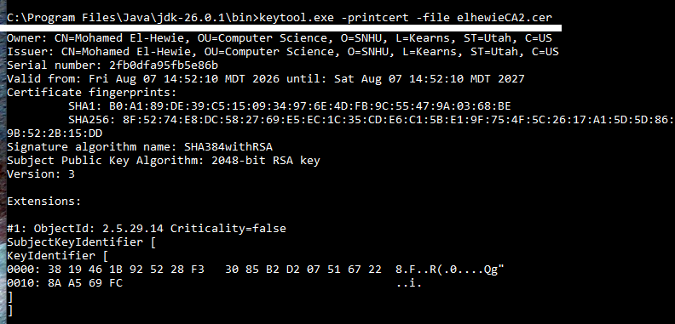

Deploy Cipher

After generating and placing the keystore.p12 file into the Java project's resources folder, the build process completed successfully and initialized the Tomcat server on port 8443. Although accessing localhost over HTTPS triggered a expected "Not Secure" browser warning due to the use of an untrusted, self-signed certificate, the SSL/TLS configuration successfully resolved the local security blocks, ultimately allowing the program to execute and display the hash value of the input string as follows:

Secure server access by refactored SslServerApplication with certificate of authority

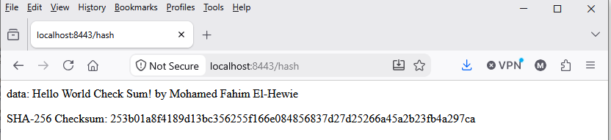

The above screenshot shows the provided string:

“Hello World Check Sum! By Mohamed Fahim El-Hewie”

That is hashed into the following secure 64-character hexadecimal string:

“253b01a8f4189d13bc356255f1166e084856837d27d25266a45a2b23fb4a297ca”

Secure Communications

Successful integration of the security certificate with the Java application is demonstrated by the running application concurrently with secure server at “https://localhost:8443/hash.” As shown below, the system securely transmits data and successfully generates the expected hash from the provided string.

Screenshot of a refactored code and application.propertties

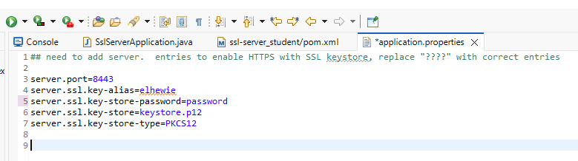

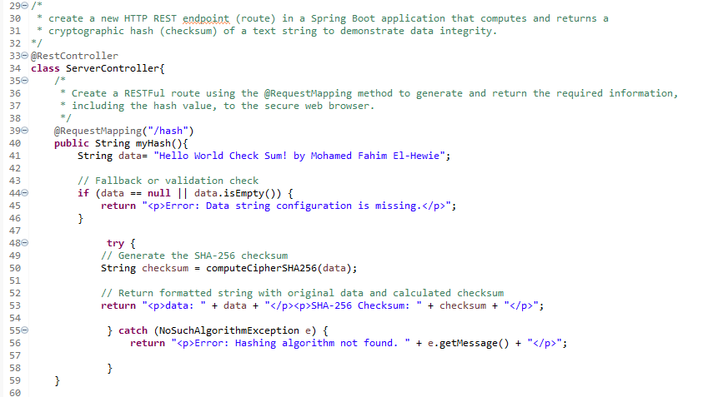

  - Screenshot of a refactored code integrated with certificate of authority

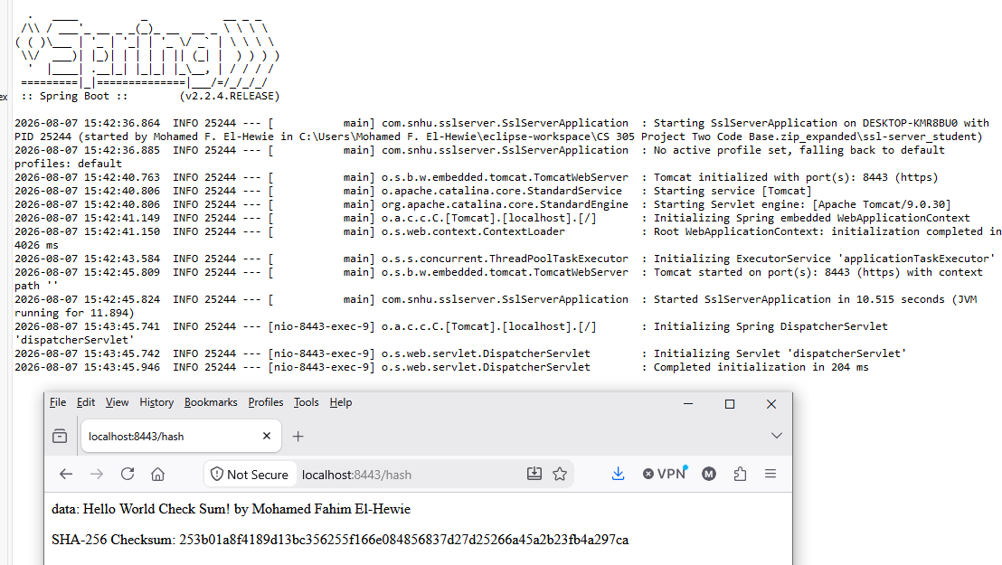

The self-signed generated certificate for local testing caused the browser not to recognize the issuing authority. It displayed a "Not Secure" warning. It technically turned an HTTP server onto an HTTPS server for encryption, but showed security warnings because no trusted Certificate Authority (CA) signed it. (Eclipse Jetty).

Secondary Testing

Before suppressing false-positive vulnerabilities, we have reported the following dependency-check (see Module Six: “6-1 Coding Assignment: Modifying Vulnerability Reporting”):

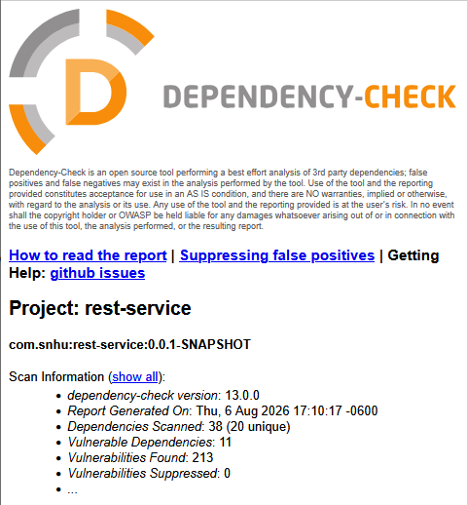

After refactoring the SsLSeverApplication code with the self-generated certificate enhancement, the compiled code was successfully built and run, as shown below:

A. The screenshot of successful build in Eclipse IDE for running java code:

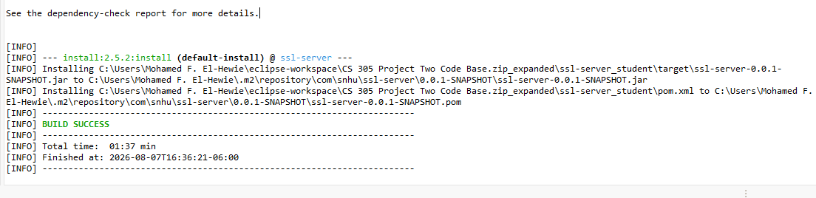

B. The HTML dependency-Check File of SslServerApplication:

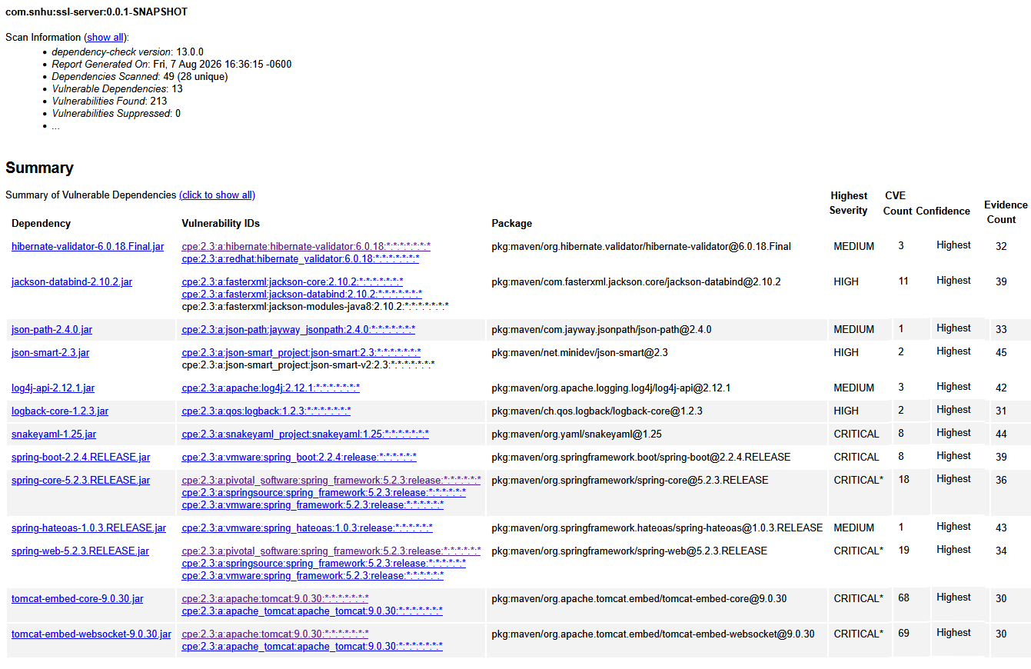

Functional Testing

Based on a manual review of the SslServerApplication.java Spring Boot code, the following vulnerabilities were observed:

- Secure API Interactions:
The Maven pom.xml file contains the following vulnerabilities:
- The <nvdApiKey> contains a plaintext credential (exposed API Key) which should never be committed to source control.
- Spring Boot Version 2.2.4.RELEASE is outdated and contains multiple security vulnerabilities and dependencies that have reached end-of-life.
- Java Version 1.8 is legacy and no longer receives critical security updates.

- Secure Coding Practices and Patterns:
The Spring Boot configuration contains critical security vulnerability as follows:
- The server.ssl.key-store-password property stores the keystore password in clear text, which exposes the private key to attackers.
- The configuration does not specify allowed SSL/TLS protocols (e.g., TLSv1.3), which exposes it to older, insecure protocols if not enforced by the runtime environment.
- server.ssl.key-store=keystore.p12 relies on a relative path. If the application runs from a different working directory or inside a packaged jar/war, it may fail to locate the file.
- Client trust store configurations (server.ssl.trust-store) are missing if mutual TLS (mTLS) or custom certificate authorities are needed,
- Explicitly setting server.ssl.enabled-protocols=TLSv1.2,TLSv1.3 is recommended to prevent legacy protocol usage.

  - Encapsulation: Secure Data Structures:
- Hardcoded variable data string contains a specific static name preventing it from calculating a checksum for any actual dynamic user data.
- Cross-Site Scripting (XSS) could occur through the hardcoded data variable in myHash() method enabling an attacker to execute malicious scripts in the client's browser context.
- The catch (NoSuchAlgorithmException e) appends e.getMessage() directly into the HTML response string which could reveal backend architecture details to attackers.

  - Code Review: Data Access:
- The ServerController class is marked as the package-private and should be declared as public to ensure seamless component scanning across various packages.
- The expression input.getBytes() relies entirely on the host environment's default charset (e.g., UTF-8, UTF-16, or ISO-8859-1) which could change when migrating to a server with a different default system charset which would spoil the generated hash value for the exact same input string.

Post-Refactoring Code Runs

After refactoring the code of SslServrApplication.java, to correct the above errors, I ran the code in both Java and Maven architectures, the following screenshots are explained correspondingly.

Running as a Java Project

The code compiled and ran successfully, allowing access to the secure server http://localhost:8443/hash, as shown below:

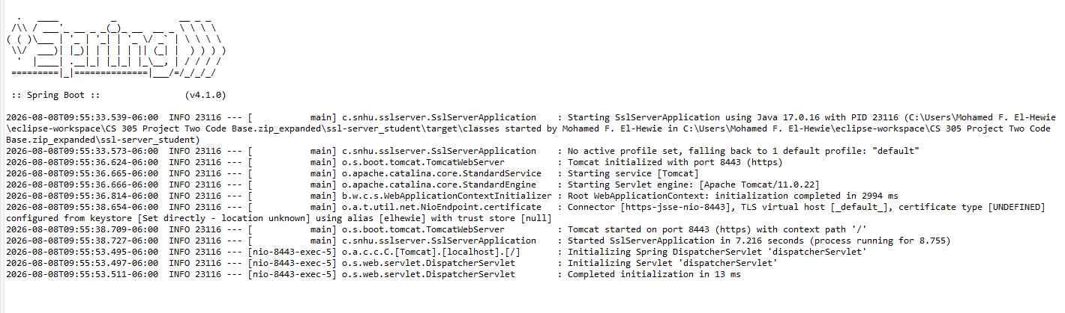

The secure access to local server was only possible while the code was running with the certificate of authority installed into the keystore.p12, placed in project’s resources folder.

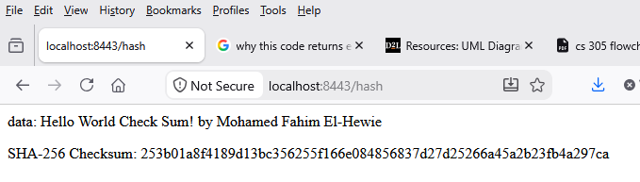

Running as a Maven Project:

Running SslServerApplication as a Maven project built successfully and completed dependency checks, reducing vulnerabilities from 213 in legacy Java and Spring Boot versions to just 10.

Screenshot of Eclipse Console of successful built project

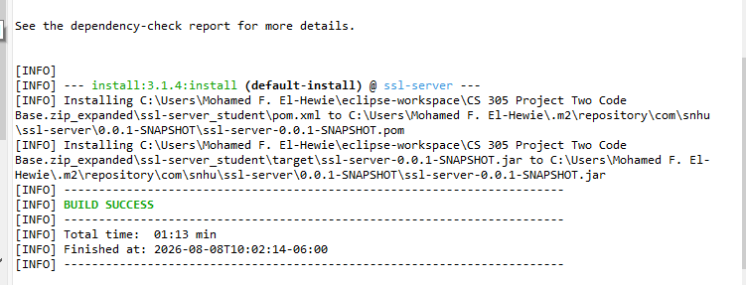

The screenshot of the HTLM of the Dependency-Check Report

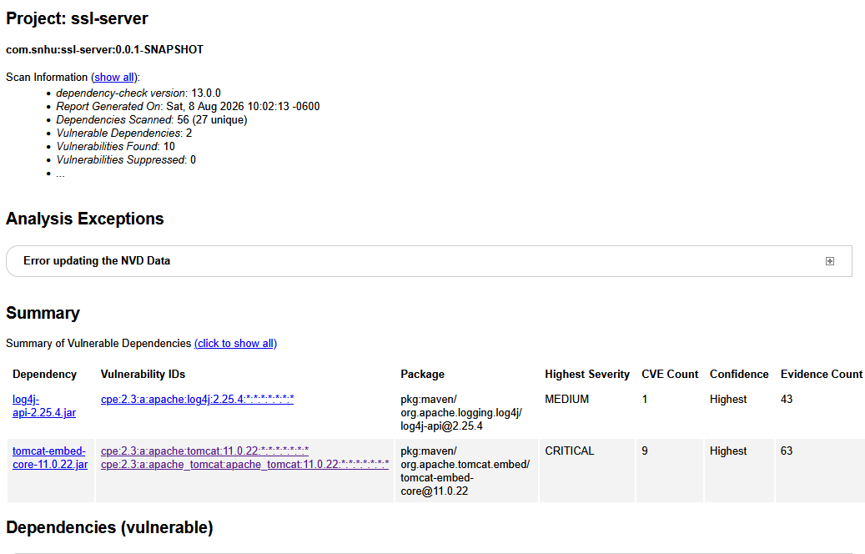

Summary

A. Refactoring code for secured data and flawless code:

- Refactoring code for flawless code:

o Static Application Security Testing (SAST): Analyze source code against the “Vulnerability Assessment Process Flow Diagram” to detect hardcoded credentials and flawed syntax before compilation.
o Dynamic Application Security Testing (DAST): Test the compiled, running application against simulated external attacks.
o Software Composition Analysis (SCA): Run dependency checks to flag and update vulnerable or outdated libraries.
o Secure Transport Enforcement: Implement TLS/HTTPS and manage valid certificates to secure communication channels and verify operational compliance.
o Code Refactoring: Update legacy code patterns to support secure transport and communication standards.
o Remediation Loop: Execute a four-step cycle (identify, categorize, fix, re-verify) for secure development lifecycles (SDLC), as follows:

- Review code: Find weaknesses early using manual checks or automated tools.
- Categorize risks: Sort issues by severity using standards like the OWASP framework.
- Fix flaws: Rewrite unsafe code with secure libraries.
- Re-verify: Test the app to ensure fixes work and break nothing.

- Refactoring code for secure cryptography:

Refactoring safely improves software security by cleaning code structure, reducing system complexity, and making hidden vulnerabilities easier to spot and fix before attackers exploit them as follows:

- Secure Communication is achieved by replacing legacy, unencrypted web protocols by enforcing HTTPS and disabling insecure HTTP channels. This establishes transport-layer security using CA-signed certificates managed via tools like Java Keytool.
- Cryptographic Integrity is achieved by replacing weak or non-existent hash implementations with industry-standard cryptographic algorithms (such as SHA-256 for hashing or AES for encryption). It removes hardcoded strings in favor of secure cryptographic verification to ensure data integrity.
- Encapsulate plaintext passwords, API tokens, and cryptographic keys out of static configurations (like application.properties) by migrating them into protected environment variables or secure vault registries.
- Implement robust input validation and updated exception handling to block injection vectors and stop systemic internal leaks via system error traces.

B. Adding multi-layers of Security:

Implementing a robust multi-layered software architecture is achieved as follows:

- Secure the Transport Layer by converting all HTTP communication routes to HTTPS, generate cryptographic keys and keystores using command-line utilities (such as keytool -genkeypair) to encrypt and sign network traffic, enforce standard transport port configuration rules (e.g., directing traffic explicitly through port 8443 or 443).

- Establish Application-Level Boundary Defenses by robust input sanitization filters at every endpoint controller to catch and nullify malformed parameters, integrate standardized security libraries to govern user session authentications, preventing execution anomalies or injection attempts, standardize global exception handlers so that any internal processing failures output sterile, custom user messages rather than raw database or structural system traces.

- Harden Data Storage and Integrity Defenses by isolating variable-state elements by using runtime-bound algorithms rather than static checksum parameters, encrypting highly sensitive database tables using dynamic symmetric keys while enforcing strict isolation role using the principle of least privilege.

C. Industry Standard Best Practices:

i. In this assignment, implementing industry-standard secure coding practices involves three key phases: scanning dependencies with tools like OWASP Dependency-Check, enforcing secure configurations in pom.xml, and applying static analysis security testing and validating all inputs during development to prevent costly post-release code redesigns.

- The first phase of checking vulnerable dependencies begins by running the OWASP Maven Plugin during every build to find known flaws in third-party libraries. This process triggers immediate updates when patches release to block public exploits. It also requires restricting snapshot dependencies in production builds and using a private repository manager to vet and approve external artifacts before the team uses them.

- The second phase of secure build configuration enforces HTTPS for all repository URLs, enables strict compiler flags for early error detection, vets released artifacts to ensure authenticity, and removes unused dependencies to minimize the overall attack surface against tampering and man-in-the-middle attacks.

- The third phase of Java code integration sanitizes all user inputs, uses secure environment variables to prevent hardcoded secrets, and logs security events safely without exposing private data or system paths.

ii. In conclusion, implementing secure coding best practices protects organizations from devastating data breaches, mitigates legal liability, and fosters long-term customer trust. By addressing security flaws early during the design phase rather than post-release, companies significantly reduce remediation costs and prevent severe regulatory fines associated with data privacy compliance violations. Furthermore, writing clean, defensive code limits system crashes, blocks pervasive threats like injection attacks, and simplifies future updates for development teams. Ultimately, maintaining reliable and secure software ensures business continuity, streamlines legal and compliance audits, and provides a distinct competitive advantage when winning clients who demand verified data protection.

REFERENCES:

- Manico, J., & Detlefsen, A. (2014). Iron-clad Java: Building secure web applications. McGraw-Hill Education.
- Dizon, M. A. C., & Meehan, A. (2025). Technical principles and protocols of encryption and their significance and effects on technology regulation. Information & Communications Technology Law, 34(2), 79–105.
- Antal, E., Mírka, J., & Kováč, D. (2026). Development of obfuscation techniques in Vienna during the early modern era. Cryptologia, 50(3), 191–221. doi.org.

Configuring SSL/TLS KeyStores.

https://jetty.org/docs/jetty/12.1/operations-guide/keystore/index.html

